MWR TICKETS AND TRAVEL

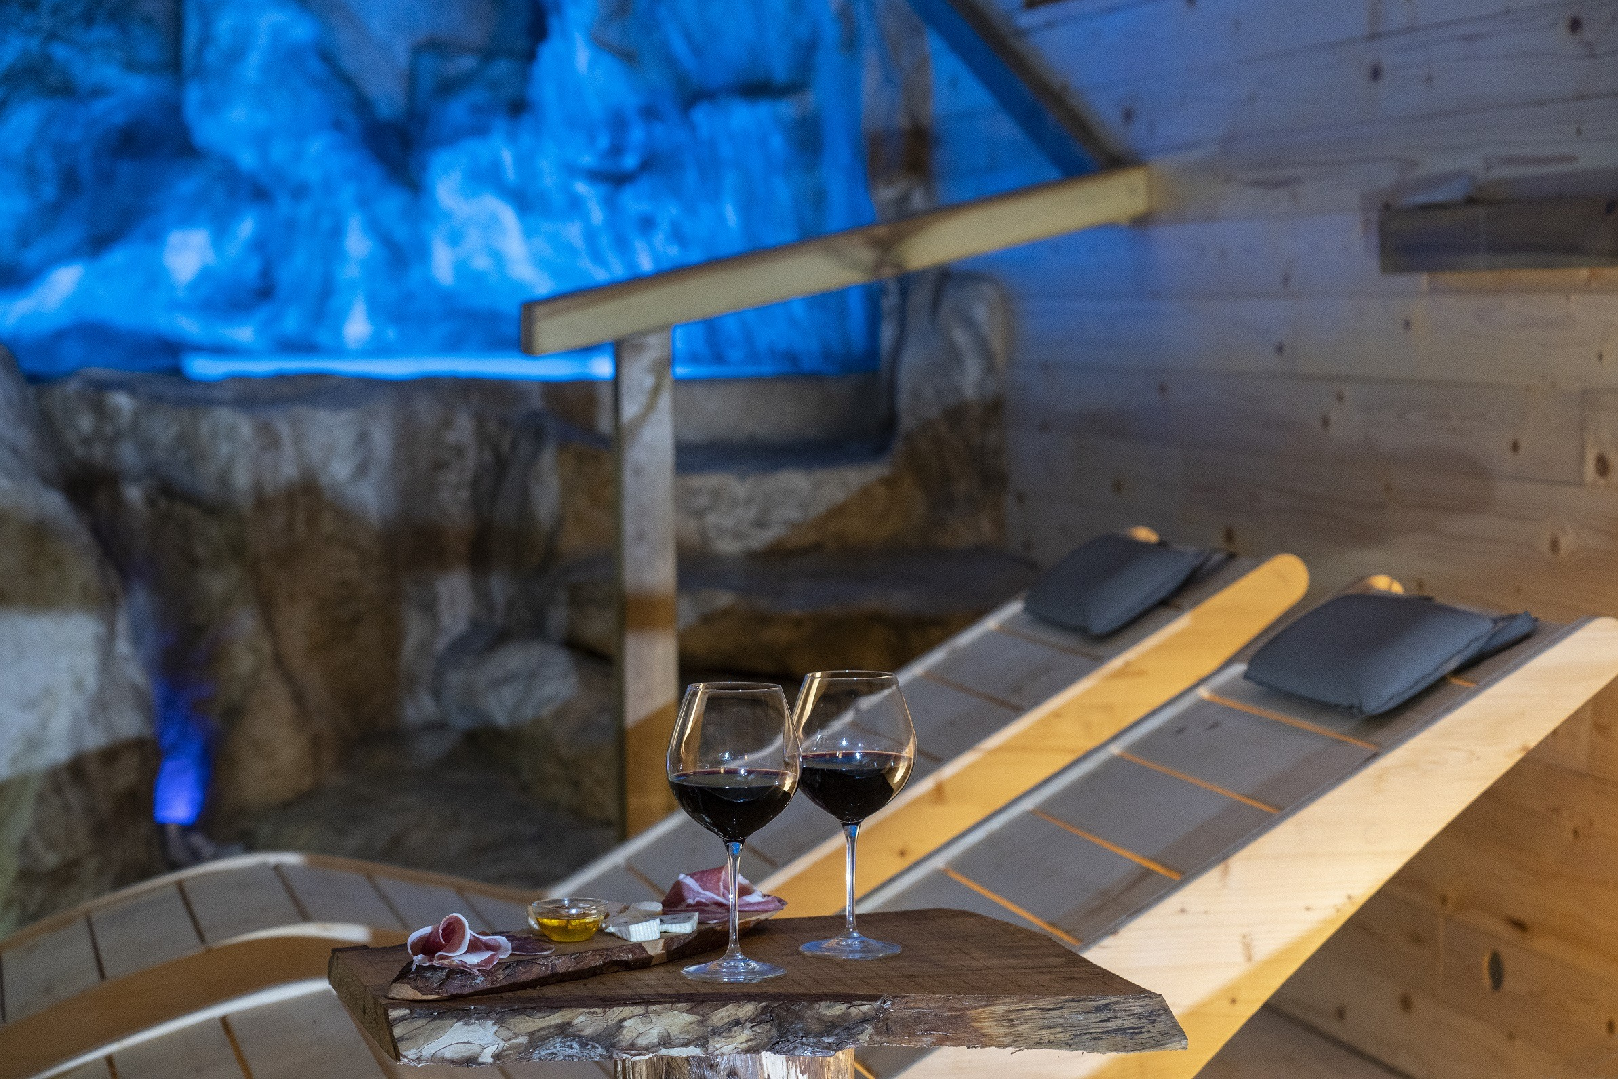

Valentine’s Getaway
Friday-Sunday, Feb. 14-16
Atena Lucana, Italy

Itinerary (Subject to changes beyond MWR control.)

Friday, Feb. 14
10:30 a.m. Depart Support Site. Please arrive by 10:15 a.m. Lunch on the way (on your own).
1:30 p.m. Arrive and check in at Villa Venus Resort and Spa (https://www.hotelvillavenus.it/?langu=en)
Evening Valentine’s Day dinner

Saturday, Feb. 15
7 a.m-1 p.m. Breakfast and lunch
Morning or afternoon Private spa for three hours
Evening Dinner*

Sunday, Feb. 16
Morning Breakfast
Noon Check out of hotel and return to Support Site
Evening Arrive at Support Site

*Two-hour cooking class with chef and dinner with wine, is optional for €80 per person.
Book the class upon check-in at hotel.

Trip includes
Bus transportation
Two nights in a 4-star hotel with breakfast daily and wi-fi
Valentine’s Day dinner (welcome drink, starter, first and second courses with side dishes, dessert, water and one glass of wine)
Lunch at hotel
Three hours of private spa
Dinner
Group leader
Cost
$466 adult per double occupancy
$525 adult per single occupancy

Payment Policy
Nonrefundable deposit of $200 per person due at registration, unless Tickets & Travel cancels trip.

Package is nonrefundable after (date TBD), 2025. Package is transferable.
Capodichino Tickets &Travel 081-568-4330 DSN 626-4330 https:\\myffr.navyaims.com
Support Site Tickets & Travel 081-811-7909 DSN 629-7909 www.navymwrnaples.com

